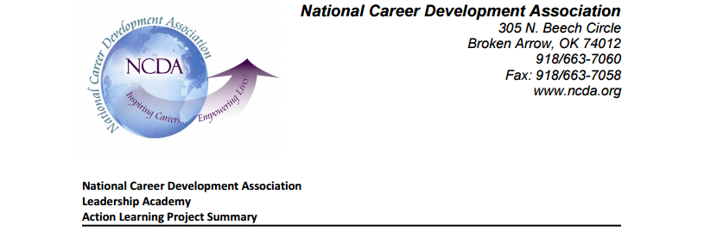
Participant: Kristy Jackson
Board Member: Mark Danaher
Leadership Academy Class: 2016
Project Title: NCDA Partnerships
Project Description: The purpose of the project is to assist the NCDA board and staff in evaluating the effectiveness of existing partnerships. Specifically, the project seeks to:
- Develop a resource that can be used by board & staff, to guide discussions about the status of existing partnerships, as well as where to invest time and resources
- Consider strategies to improve the effectiveness of their most viable existing partnerships
Summary
I conducted preliminary research on our existing partnerships and researched best-practices in collaboration as part of non-profit strategic planning and capacity-building. The findings are being used to draft a tool that could be used to help the board in evaluating the viability of existing partnerships.
Findings:
Partnerships: The NCDA has arrangements with many partners. Some are loosely defined but a few are more structured. With limited staff time and changes in board leadership, some partnerships are in question. Also, many of the responsibilities of sustaining partnerships seem to fall on Board members, who may or may not have a personal/professional interest in maintaining the arrangement.
Effectiveness: There is a question as to the effectiveness of certain partnerships and a hesitancy to invest in the pursuit of new collaborations, even if new arrangements might help meet existing 20/20 goals. Without strategies for sustaining the most valuable partnerships, potentially viable relationships could be at risk during times of board transition. There seems to be opportunities to better align state CDAs at a grass-roots level with these viable partnerships as well. Similarly, some partnerships have an unclear purpose, which gives the impression that the cost of sustaining, or opportunity-cost, might not meet the investment of resources. Some of the partnerships do not appear to have an intention of collective impact.
Evaluation / impact: It is unclear if established partnerships are evaluated, and by whom. For example, how is the NCDA better or more effective because of a partnership. A few of the newer collaborations appear to be more strategic and results-oriented. Organizations are dynamic and ‘living’, so changes in partnership (both starts/ends) are to be expected.
Results / Recommendations for Managing External Relations During a Transition
A combination of results-based MOUs, an investment of staff time & staff training, and engagement strategies at multiple levels within NCDA would increase the effectiveness and momentum of our most promising partnerships. Strategies to consider include:
Leadership: Building effective partnerships takes an investment of time, as well as efforts to align goals, equip players, and sustain the effort. Thus, it might behoove the organization to put NCDA’s strategic focus on a managerial level staff person. This doesn’t necessarily mean that the staff person would be the ‘face of the organization’ to all of the external partners, but rather that this person would drive the initiatives across multiple channels within our organization. A staff-member could also be responsible for data collection for evaluation purposes as well as the strategic mobilization of association resources.
Evaluation:
Several of our partners agree to promote our events. Are they? Some are. With one partner, there was lots of evidence that we were promoting their upcoming event, but I didn’t uncover any evidence of the opposite. Depending on what the NCDA hopes to gain from these informal arrangements, we might consider tracking if the relationship results in new attendees, subscribers, members, sponsors, collaborators, advisors, followers, or page-hits, etc. Does it result in enough benefit to offset the costs of sending someone to their event? Consider monthly or quarterly reporting; perhaps have constituent groups, board members, and State presidents send a quarterly report of how they have supported the partnership to the NCDA staff person in charge of partnership/strategy, who could then compile the data and share evidence of impact with members and other stakeholders.
Grass-Roots Engagement: Opportunities exist to engage influential members from deeper within the organization. Consider using technology to involve State and Constituent groups in a cost-effective manner. For example, using a Skype call, or a webinar format, ask a rep from ACTE to discuss issues that are of interest to school-counselors as well as funding that is available to them for ACTE/regional CTE conference travel. The discussion from these communications could be highlighted in our magazine, website, and social media. Making these Skype/webinar communications available for CEUs might help to get initial interest among our members.
Other ideas to contemplate:
*Rather than limiting travel to board members, consider asking partners to invest in travel scholarships for members of State CDAs to travel to regional conferences in their area. (Ex: use funding to send a few members of a State CDA to a State CTE event, and vice versa).
* Consider other arrangements. Try collaborating on one project before naming a group as a partner. Are they good to work with? Is there potential for greater collective impact? Does it make sense to partner officially, or do other arrangements make more sense: Champions? Sponsors? Volunteers? Alliances?
* Consider aligning with organizations that match our values. For example, rather than aligning primarily with other ‘career groups’, consider a broader scope when evaluating potential partners. For example, equity groups or workforce groups can match-up with multiple constituent groups within NCDA, which broadens the appeal and positions our organization with a new audience.
* Leadership/career development of existing staff: If partnerships/strategic alliances are a priority for NCDA, does training for capacity-building/external relationships fit into a development plan for any of our existing staff? For non-profits, a best practice of a board is to make the development of staff a reality and not simply a line-item: http://www.thenonprofitpartnership.org/files/dk_nonprofitleadershipstudy.pdf (p 25) Or, would it be better to hire a consultant? Or hire an additional staff member? There are many things for the board to consider as they are evaluating partnerships and planning for the future.

*Future LA Projects could take these findings, and further survey NCDA members and ACTE or AF members about how they would like to see the collaboration progress. Or, survey NCDA members to assess their awareness of a particular partnership. Or, develop a PDI on capacity building & collaboration. Or, conduct an assessment of career development needs/interests of staff and look for connections to organizational goals.

Sources:
Community Toolbox, “Section 8: Identifying and Analyzing Stakeholders and Their Interests”
http://ctb.ku.edu/en/table-of-contents/participation/encouraging-involvement/identify-stakeholders/main

Creating and Sustaining Effective Partnerships, http://www.wa.gov/esd/training/elearning/business/01-06.pdf
Leading and Managing Change: Align, Equip, Sustain http://www.axiomcp.com/wp-content/uploads/2015/07/Leading-and-Managing-Change-Final_0.pdf
Managing Through Change and Leading Through Transitions, http://communityinitiatives.com/wp-content/uploads/2015/07/Managing_Change_Leading_Transitions.pdf
Non Profit Answer Guide – Leadership FAQ’s, “What is all This Talk About Capacity Building”, http://nonprofitanswerguide.org/leadership/
Non-Profit Leadership Development, A model for identifying and growing leaders within the nonprofit sector, http://www.thenonprofitpartnership.org/files/dk_nonprofitleadershipstudy.pdf
Partnerships: Framework for Working Together, http://strengtheningnonprofits.org/resources/e-learning/Online/partnerships/Print.aspx
WORKING BETTER TOGETHER: BUILDING NONPROFIT COLLABORATIVE CAPACITY, https://www.michiganfoundations.org/sites/default/files/resources/Working-Better-Together-GEO-2013.pdf

