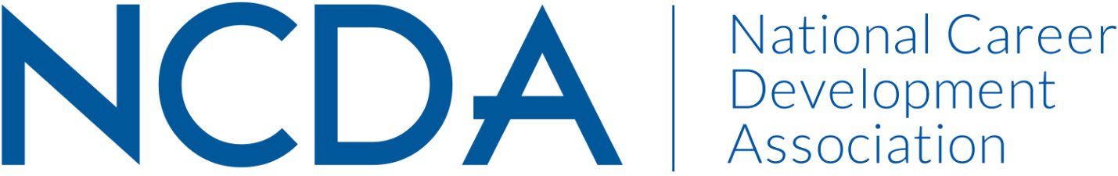

Mid-Year Report

ETHICS COMMITTEE
3/15/21

Co-Chairs:
Azra Karajic Siwiec PhD, LPC  330.360.5575  akarajic@aol.com | Sarah Patterson Mills PhD, LPC  209 South Kings highway  St. Charles, MO 63301  Spatterson-mills@lindenwood.edu  636.949.4181

Members

Members
Name | Email address
Sharon Anderson | sharon.anderson@colostate.edu
Amanda Chenkin | choicecareercounseling@gmail.com
Diane Farrell | diane.farrell@ung.edu
Amanda Friday | af973@georgetown.edu
Conquaya James | ConquayaJames@hotmail.com
Azra Karajic Siwiec | akarajic@walsh.edu
Jaana Kettunen | jaana.h.kettunen@jyu.fi
Amrit Mundy | Amrit.mundy@ubc.ca
Sarah Patterson-Mills | SPatterson-Mills@lindenwood.edu
David Reile | David@reile.com
Keley Smith-Keller | keley.smithkeller@yahoo.com
Angela Smith | acsmith5@ncsu.edu
Stacy VanHorn | stacy.vanhorn@ucf.edu
James Westhoff | westhoffj@husson.edu
Carolyn Jones | carolyn8347@gmail.com
Rep to the board: Julia P. Makela | jpmakela@illinois.edu

 | Activities to Date
 | Goals and Objectives | Activities Completed
 | Member inquiries  Team Leaders: Azra Karajic Siwiec & Sarah Patterson Mills | Ongoing: Continue to respond to ethics inquiries regarding questions about ethical dilemmas or requests for more information about the Ethics Code.
Ethics column in the Career Developments Magazine  Team Leader: Sarah Patterson-Mills |  | Ongoing: Submit articles to the Ethics in a Nutshell column for the Career Developments Magazine by Ethics Committee Members and other invited authors  Summer 2020: Rural Workforce Development: Poised for Growth, Rebecca Merlenbach & Sarah Patterson-Mills  Fall/Winter 2020: Disrupt Career, Billie Streufeurt  Spring 2021: Diane Farell and Keley Smith-Keller, Ethics with Changing Technology
PDF Ethical dilemma short guide  Team Leader: Julia Makela |  | Developing a graphical representation of steps to take for resolving an ethical dilemma we can share at the following NCDA conferences; COVID 19 pandemic put a standstill on this
NCDA Code of Ethics Editing process  Team Leader: Azra Karajic Siwiec |  | Developed a survey which will be shared among NCDA committee leader as we seek to incorporate feedback from NCDA members into our editing process (this will be an ongoing process for us appearing in our plan of work for a couple of years starting now)

Projected Plan through fiscal year end (September 30th)
Member inquiries  Team Leaders: Azra Karajic Siwiec & Sarah Patterson Mills | Ongoing: Continue to respond to ethics inquiries regarding questions about ethical dilemmas or requests for more information about the Ethics Code.
Ethics in a Pandemic webinar  Team Leader: Azra Karajic Siwiec, Sarah Patterson Mills | Webinar is scheduled for May 4th, 2021 1:00 PM ET and will include Azra Karajic Siwiec, Stacey Van Horn, Amanda Chenkin, & Sarah Patterson-Mills.
NCDA Code of Ethics Editing process  Team Leader: Azra Karajic Siwiec | NCDA Code of Ethics process will continue for the next couple of years.

