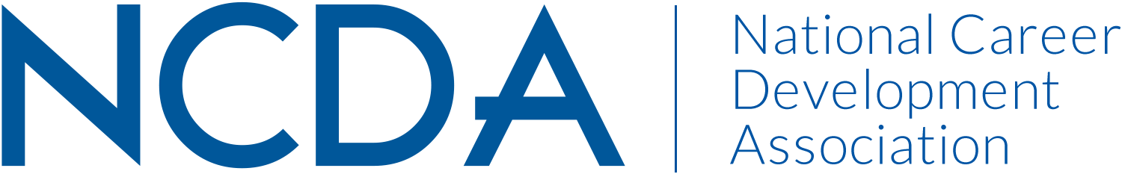

Mid-Year Report 2020-2021

INTERNATIONAL STUDENT SERVICES COMMITTEE
Date of Report: March 15th, 2021

- Co-Chairs: Un Yeong Park, park351@illinois.edu & Arame Mbodj, arame@stanford.edu
- Members: See list of 32 members attached chart on page 2

Activities to Date:

- Three General Meetings were held; October 8, December 10, and February 11. Three sub-teams, two writing groups, and a taskforce team hosted more than 40 meetings over the last five months.
- The Committee issued the NCDA Support Statement for International Students on October 30, 2020 to advocate for international students facing significant challenges during the pandemic.
- Current and former leaders of the Committee published Advocating for International Student Wellbeing and Career Development in the Pandemic on Career Convergence on March 1, 2021.
- The Research team has been focused on three projects: 1) writing a manuscript for the action research project on multicultural, social justice, and advocacy strategies for career counseling with int’l students and preparing to present it at the 2021 NCDA Virtual Conference; 2) collaborating with the Social Media team to create YouTube videos based on the Research team’s work; 3) revising and launching the updated survey regarding international students’ career development.
- The Social Media team is expanding our social media presence by strategically increasing engagement in our LinkedIn Group (established in 2012) which now has almost 600 members in this online community. We are also excited to be launching a YouTube Channel to showcase the work and expertise of the members of the ISSC. With the creation and curation of video resources, we will further expand our reach and impact on other professionals working within the career development of international students. The team is also in the middle of a brand creation to accompany the YouTube Channel's launch.
- The Resources Team updated the NCDA website resources by relocating the member-only resource guide and one-page resource to increase visibility. The team updated the description of international student resources under the NCDA special population page to highlight the resources created by ISSC while following the format that other special population resource sections used for consistency.

Projected Plan through fiscal year-end (September 30):
- To host 2021 ISSC Mini-Conference (August 6 & August 13): Theme – Serving international students during transition: Illuminating career pathways, resources and opportunities.
- To launch the ISSC Youtube Channel with ISSC content geared towards career practitioners working with international students and a new designed ISSC logo.
- To offer two presentations at the NCDA National Conference based on the work of the committee members.
- To publish a Career Convergence article to introduce ISSC and its projects/accomplishments.

Member List

Anne Margaret Kelly | AMKCOACH/Mercer University Business School
Arame Mbodj | Stanford University
Beth Bernhardt | NYU
Beth Cooperman | CUNY Borough of Manhattan Community College
Breanna Gallagher | Oklahoma State University - Career Services
Elif Balin | San Francisco State University
Ellen Zold Goldman | Northeastern University
Fatim Lelenta | New York University, Wasserman Center for Career Development
Gaeun Seo | The Center for Career Development, Princeton University
Hongshan Shao | The Pennsylvania State University
Ivette Mekdessi | Rice University - Center for Career Development
Jane Sitter | UMN - TC
Jason Rickey | Shorelight
Joana Scharinger | Golden Gate University
Kelly Woods | Mount Holyoke College
Kendra Northington | The George Washington University
Kwan Segal | ICAway
Leigh Mason | Carnegie Mellon University, Silicon Valley
Lisa Andrews | American University
Lynette Hepburn-Richardson | Valdosta State University
Maggie Luo | ChampAmerica
Paola Barriga | University of Georgia
Ramesh Jayavaram | General Assembly
Satomi Yaji Chudasama | Princeton University
Sharena Payne | American University
Soojin Kim | Pasadena City College & Santa Monica College
Terah L. Henderson | Yorkville University
Un Yeong Park | University of Illinois at Urbana-Champaign
Vanessa Lee | UC Riverside
Xinrui (Rose) Xu | Purdue University Center for Career Opportunities
Yangyang Liu | The Pennsylvania State University
Yasir Kurt | Texas A&M University- San Antonio

