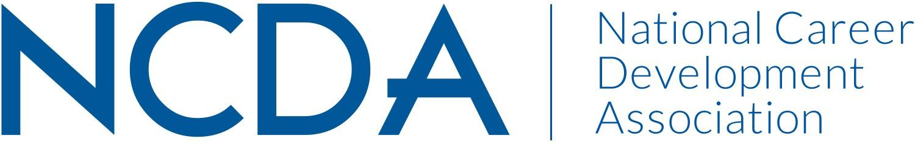

NATIONAL CAREER DEVELOPMENT MONTH COMMITTEE
March 15, 2024

Kymmie Cartledge (Co-Chair): kcartledge@lexington1.net
Cornelius Thomas (Co-Chair): corneliusthomas@johnston.k12.nc.us
Logann Todd
Meredith Brown
Alix Ruby

Committee/Council Activities to Date

- Updated brochure for the new theme
- Podcast episode for NCD month.
- Lesson plans for all grade levels related to the contest theme
- Social media toolkit for contest advertisement
- The revised national judging process

Projected Plan/Work Completed through September 30.

- Judge submissions (March/April)
- Notify state coordinators, contest participants, and NCDA members of winners (May)
- Send prizes to winners (May)
- Secure contest theme and update brochure for the upcoming contest prior to NCDA
Conference in June (before June)
- Develop new ways to celebrate winners both at the NCDA conference and virtually
- Curate resources for career development professionals (K-12 specifically) and create
- connections to the theme of the poetry and art contest and the National Career Development Month (ongoing)
- Develop a possible podcast episode for November 2024

Budget Requests: None

